

**Bullock Summer Youth and Fall Enrichment Program**

Bullock Chapel CME Church

BOCE/Youth Department

3435 Overton Rd. • Dallas, Texas 75216

Rev. James Larry, Sr. Pastor

• 214-374-6772 • 214-448-6341

[Bullockchapel@tx.rr.com](mailto:Bullockchapel@tx.rr.com) * [www.bullockchapelcme.com](http://www.bullockchapelcme.com)

September 07, 2013

Dear Business Owner, Potential Sponsor:

The **Bullock Summer Youth and Fall Enrichment** (BSYFE) program is a self-funded, non-profit curricular community activity in Dallas, TX. The BSYFE is a non-profit 501(c) 3 organization, gears towards meeting the needs of the low income inner-city neighborhoods to bring about a positive change while supporting low income youth & families by offering helpful referral resources and feeding programs, positive educational projects and activities that are designed to enrich and build lives, personal growth and increase social awareness in low-income inner-cities and communities.

**Keeping It Real**

***Keeping It Real*** Is an intensive, youth‐engagement program that addresses some of the most prevalent issues facing youth in schools today. The most dynamic & critical of all, this workshop introduces the students to the foundation of youth leadership - character & confidence building, an after school workshop focuses on enhancing self-esteem, continued education, and encourages pursuit of goals, dreams, & aspirations.

**Back to School Supply Drive and Hair Clinic**

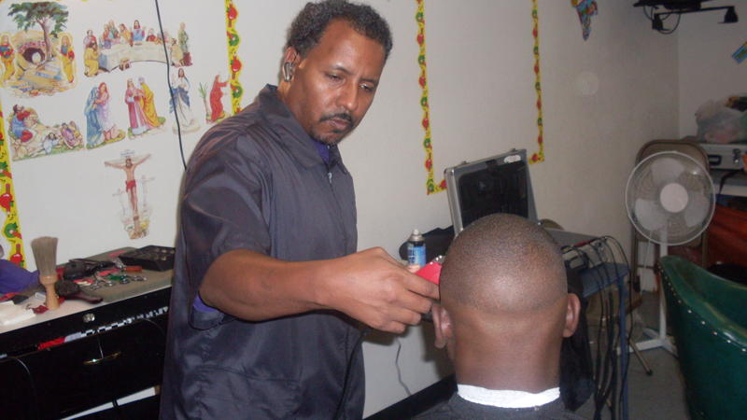Some local students are able to put their best "head forward" before beginning school because of the Back to School Supply Drive and Hair Clinic. It's a back to school haircut and hairstyles outreach for all school age children. Bullock in partnership with licensed barbers and beauticians open their doors to local children heading back to school. Students receive free haircuts & styles, educational resources, lunch, and even free school supplies. In past years, this event has been attended by well over 200 parents, students, professionals, community leaders, media and anyone seeking to give back in a special way.

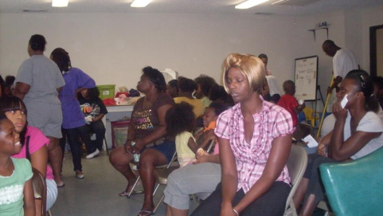

We believe going back to school you have a lot of things you have to worry about, if we can give parents one less thing to not worry about, it is a good help to the community.

Despite its big ambitions, the Bullock Summer Youth and Fall Enrichment Program has remained a self-funded, non-profit group and receives no additional funding for costs through outside organizations. Unfortunately, this has placed us in a position that could start to compromise our ability to maintain quality youth services and feeding opportunities the community has come to appreciate. Our student members and our partners know this and understand the importance of corporate sponsorship to what we do.

**Program Successes**

* This past year has been one of many successes, particularly in light of the recent program growth of participants. Thus, more staff was needed to facilitate the increase in attendees.
* In total we provide services for over 200 participants in the summer program.
* School Supplies provided to local students preparing them to be well equipped for the school year.
* Feeding more than 150 people in the community during the Holiday seasoned, (Plans to expand program to feed more than 250 this fall and a summer youth feeding program for approximately 200 a week.)
* Emphasis on promoting a safe environment for attendees
* Media coverage informing community of the free event

This is where we hope you come in. Our slogan: ***“Transforming Today’s’ Youth into Tomorrow’s Leaders”*** and **“Supporting Families Wholly”** plainly states our commitment to our Dallas area youth and their families as well as the surrounding community. We believe if we can build a solid foundation for leadership and enable resources for a “positive image”, we can continue our mission with your help. Join our efforts to provide and nurture quality leadership and opportunities. Enclosed is a variety of customized packages for business sponsorship designed to provide businesses with marketing exposure and the opportunity of profiling themselves as active contributors in the community. We would be happy to meet in person at your convenience to further define our organization and to discuss other options. We look forward to hearing from you.

Sincerely,

***Rev James Larry***

Rev. James Larry,

Senior Pastor

**For more Information or to make financial contributions visit our website:** [**www.bullockchapelcme.com**](http://www.bullockchapelcme.com/)

**All donations are Tax deductible a 501 C-3 Org.**

**SPONSORSHIP FORM**

Sponsor Name: ________________________________________________________________________________

Address: ________________________________________________________________________________

Contact: ________________________________________________________________________________

Phone: __________________________________________

Email:___________________________________________

**Platinum**

$5000+

Advertisement in program

Recognition in program/website

Company name displayed in lobby

Advance notice of shows/events

**Gold**

$2500-4999

Advertisement in program

Recognition in program/website

Advance notice of shows/events

**Silver**

$1000-2499

Recognition in program

Listed on our website

**Bronze**

$250-999

Recognition in program

Advance notice of workshops/events

**Patron**

$100-249 Recognition in program

**PATRON’S LIST**

**FUNDRAISING PROJECTS**

Sponsor: Name:_________________________________

Address: _______________________________ City: __________________________________

Contact:________________________________

Phone:_________________________________

Email:__________________________________ **Contributions**($1.00 to $99.00 or material items)

**1.__________________________**

**2.__________________________**

**3.__________________________**

**4.__________________________**

**5.__________________________**

**6.__________________________**

**7.__________________________**

**8.__________________________**

**9.__________________________**

**10._________________________**

**11._________________________**

**12._________________________**

**13._________________________**

**14._________________________**

**15._________________________**

**16._________________________**

**17._________________________**

**18._________________________**

**19._________________________**

**20._________________________**

**21._________________________**

**22._________________________**

**23._________________________**

**24._________________________**

**25._________________________**

**FUNDRAISING PROJECTS**

Sponsor: Name:_________________________________

Address: _______________________________ City: __________________________________

Contact:________________________________

Phone:_________________________________

Email:__________________________________ **Contributions**($1.00 to $99.00 or material items)

**1.__________________________**

**2.__________________________**

**3.__________________________**

**4.__________________________**

**5.__________________________**

**6.__________________________**

**7.__________________________**

**8.__________________________**

**9.__________________________**

**10._________________________**

**11._________________________**

**12._________________________**

**13._________________________**

**14._________________________**

**15._________________________**

**16._________________________**

**17._________________________**

**18._________________________**

**19._________________________**

**20._________________________**

**21._________________________**

**22._________________________**

**23._________________________**

**24._________________________**

**25._________________________**